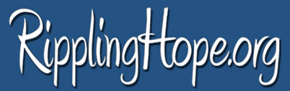

Connecting Communities…Channeling Hope…Changing Lives

BOARD UP CREWMEMBER
Role
Serve as crewmember to board up identified unoccupied homes through the Board Up Brigade program. Represent Rippling Hope organization with integrity and professionalism.

Responsibilities
- Attend paid orientation/training first week on the job
- Work daily assuring best practices and safety protocols developed by organization to board up identified houses by Crew Supervisor
- Follow verbal and written instructions of Crew Supervisor
- Use and encourage appropriate language and demeanor on work sites
- Dress appropriately in work clothes (crew t-shirt provided by Rippling Hope)
- Bring water bottle provided by Rippling Hope daily
- Maintain clean and organized work site though out the workday
- Eliminate all cell phone usage with the exception of scheduled breaks at the direction of Crew Supervisor (no headphones, music, etc.)
- Stay awake and alert at all times
- Meet weekly with direct supervisor for planning and feedback

Traits/Qualities Beneficial for Success
- Must be at least 18 years of age
- Must be a resident of the City of Detroit with a positive endorsement from a community organization/block club leader
- Basic construction experience/knowledge helpful
- Must be team player/ work well with others
- Must have reliable transportation to and from work
- Strong verbal communication skills
- Good listening skills, ability to follow direction
- Strong work ethic
- Must be able to lift up to 50 lbs.

Accountability
- Report directly to Crew Supervisor
- Maintain daily timesheet and report hours at the end of each work week
- Pass drug screening and Criminal Background Check

Compensation
Minimum of $10 hourly

